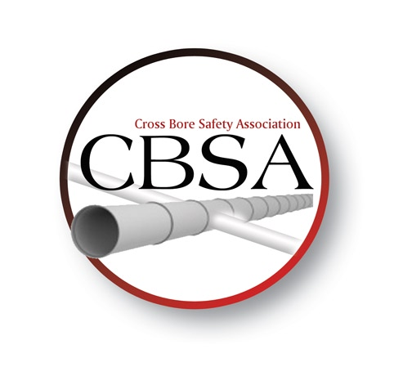
Cross Bore Safety Association
14405 SE 89th PL
Newcastle, WA 98059
www.crossboresafety.org

Date
Organization Name
Name
Address
City |  |  | State |  | Postal Code
Country
Work Phone |  | Mobile Phone
Email Address

Annual Individual Dues to CBSA $100.00

Thank you for your support.

Please remit to:
Cross Bore Safety Association
14405 SE 89th PL
Newcastle, WA 98059
812.719.4800

